MegaWiFi Password Reset On Iphone

- Go to settings on your phone. Put on your Wifi and choose the SSID teledata-megawifi.
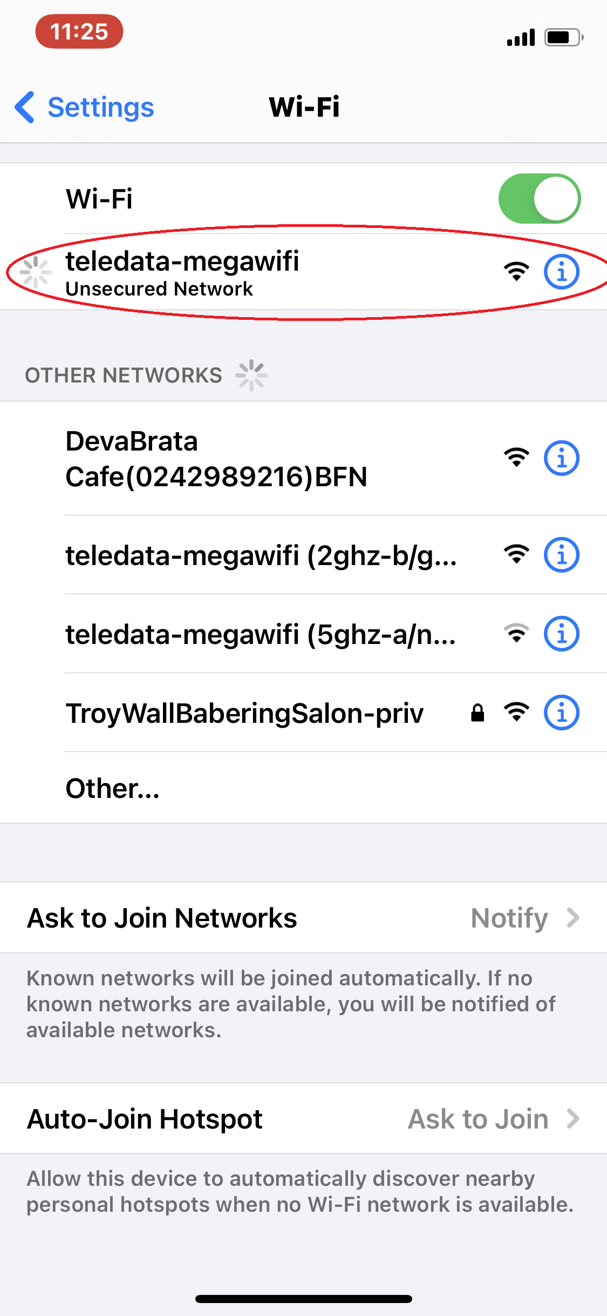

- Wait till you see a splash page open on your browser. Tap on sign-in
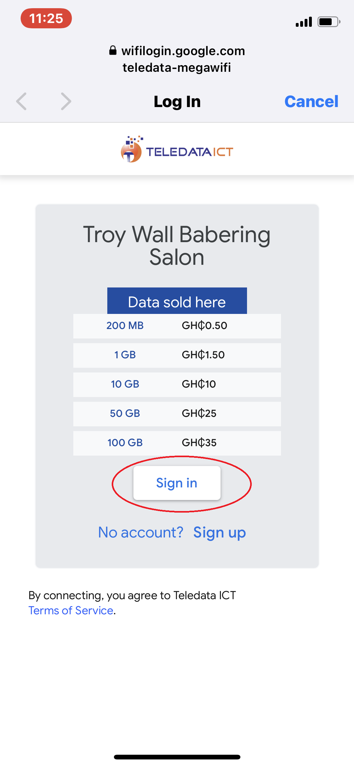
- Input your phone number in the space without adding the first zero (0).
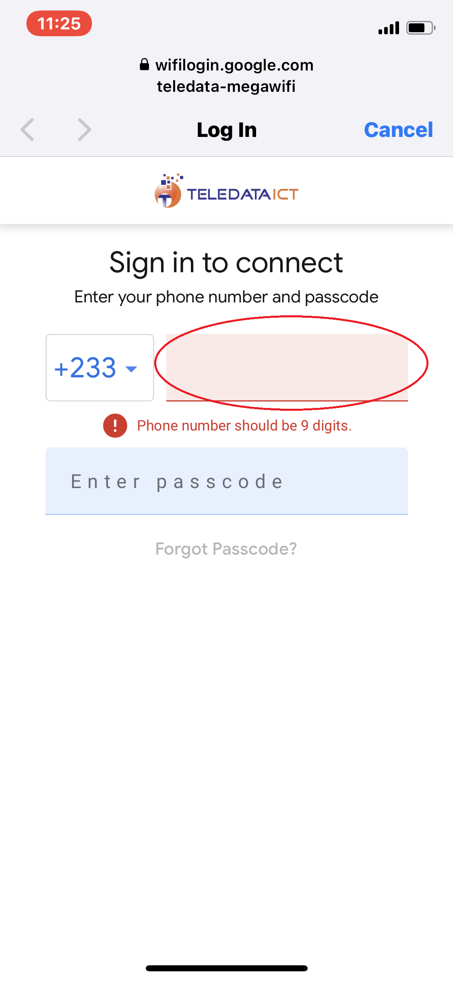
- Look beneath the Enter Passcode space and you will see forgot passcode? button highlighted. Tap on it.
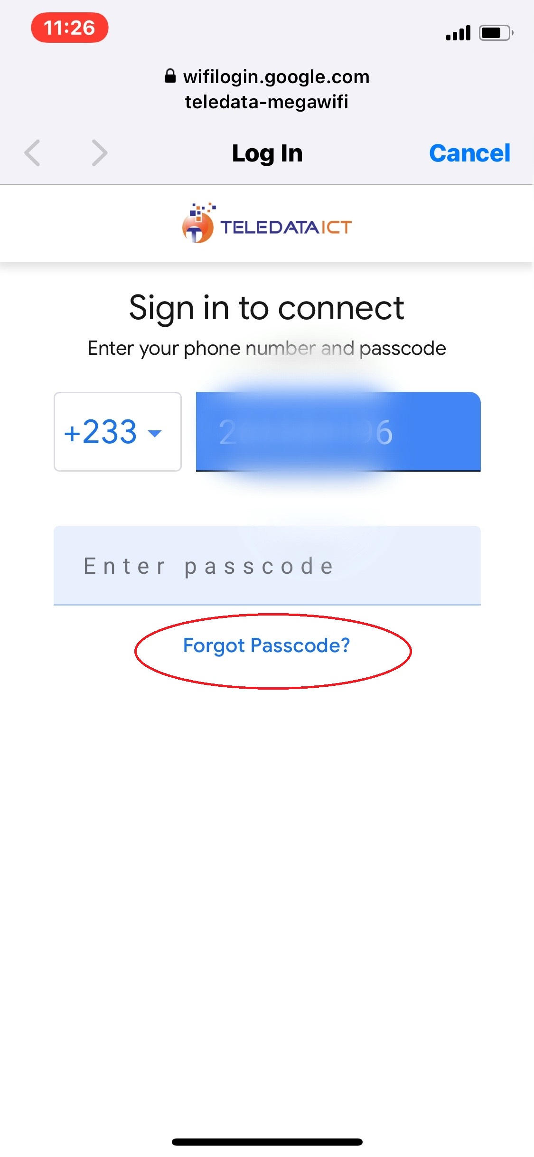
- Tap on Send PIN.
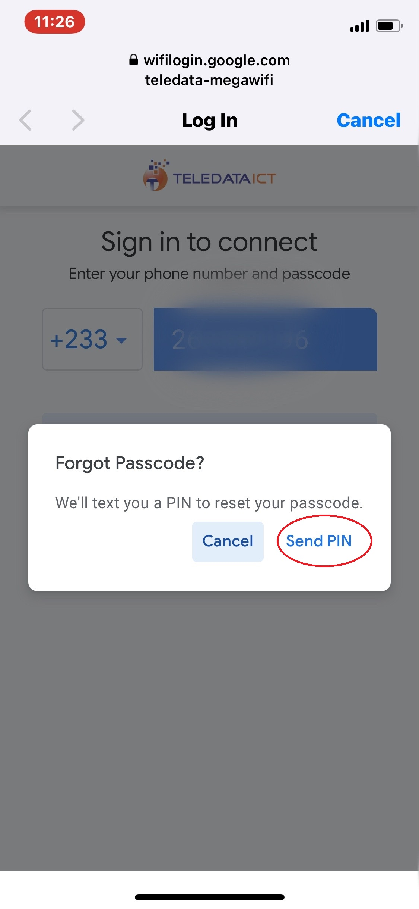
- Check your phone messages for the message “Your WIFI Verification Code is ******. The Sender name is Google and the code is 6 numbers.
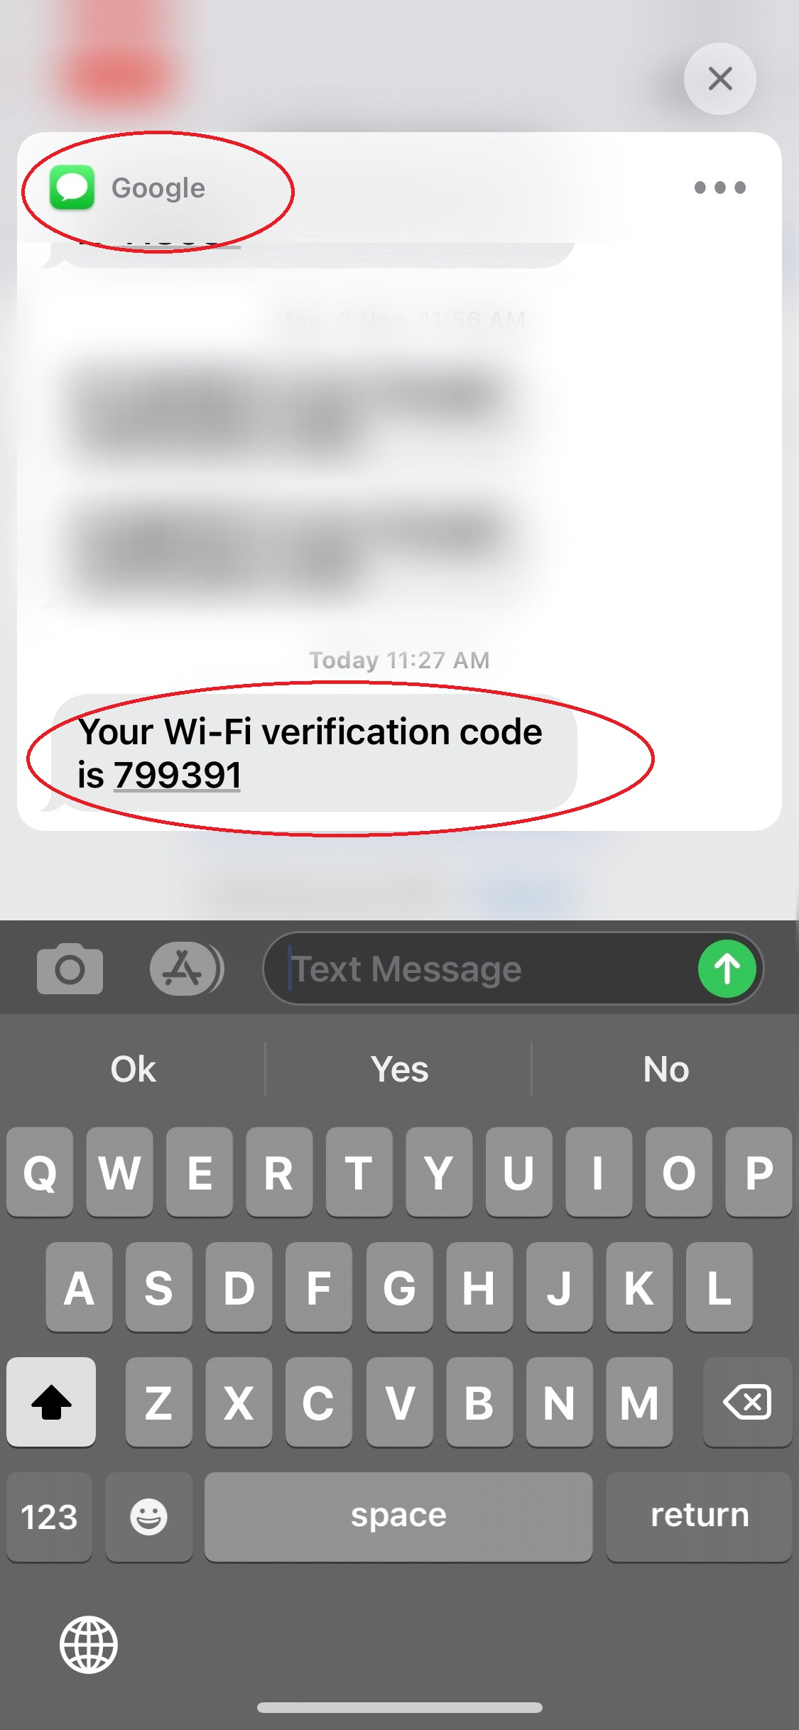
- Enter the 6 digit code into the space provided. Tap on Resend if you didn't get the message.
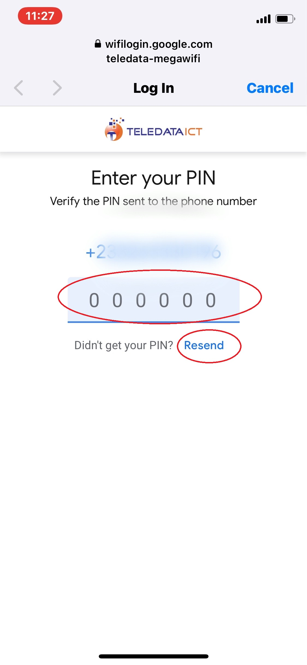
- Enter your new passcode into the space provided. Reenter the passcode into the confirm passcode space.
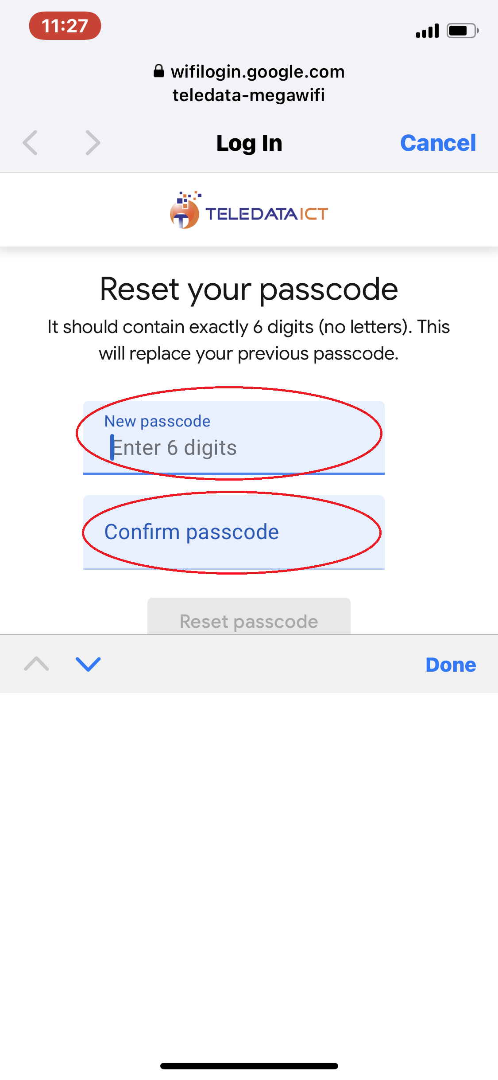
- Tap on Reset Passcode
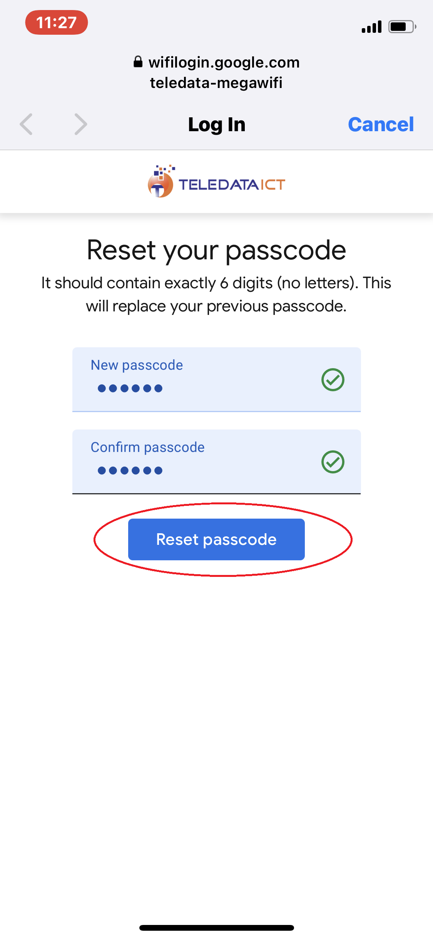
- Tap on Connect to browse if you have data. Buy data from Reseller if you don't.
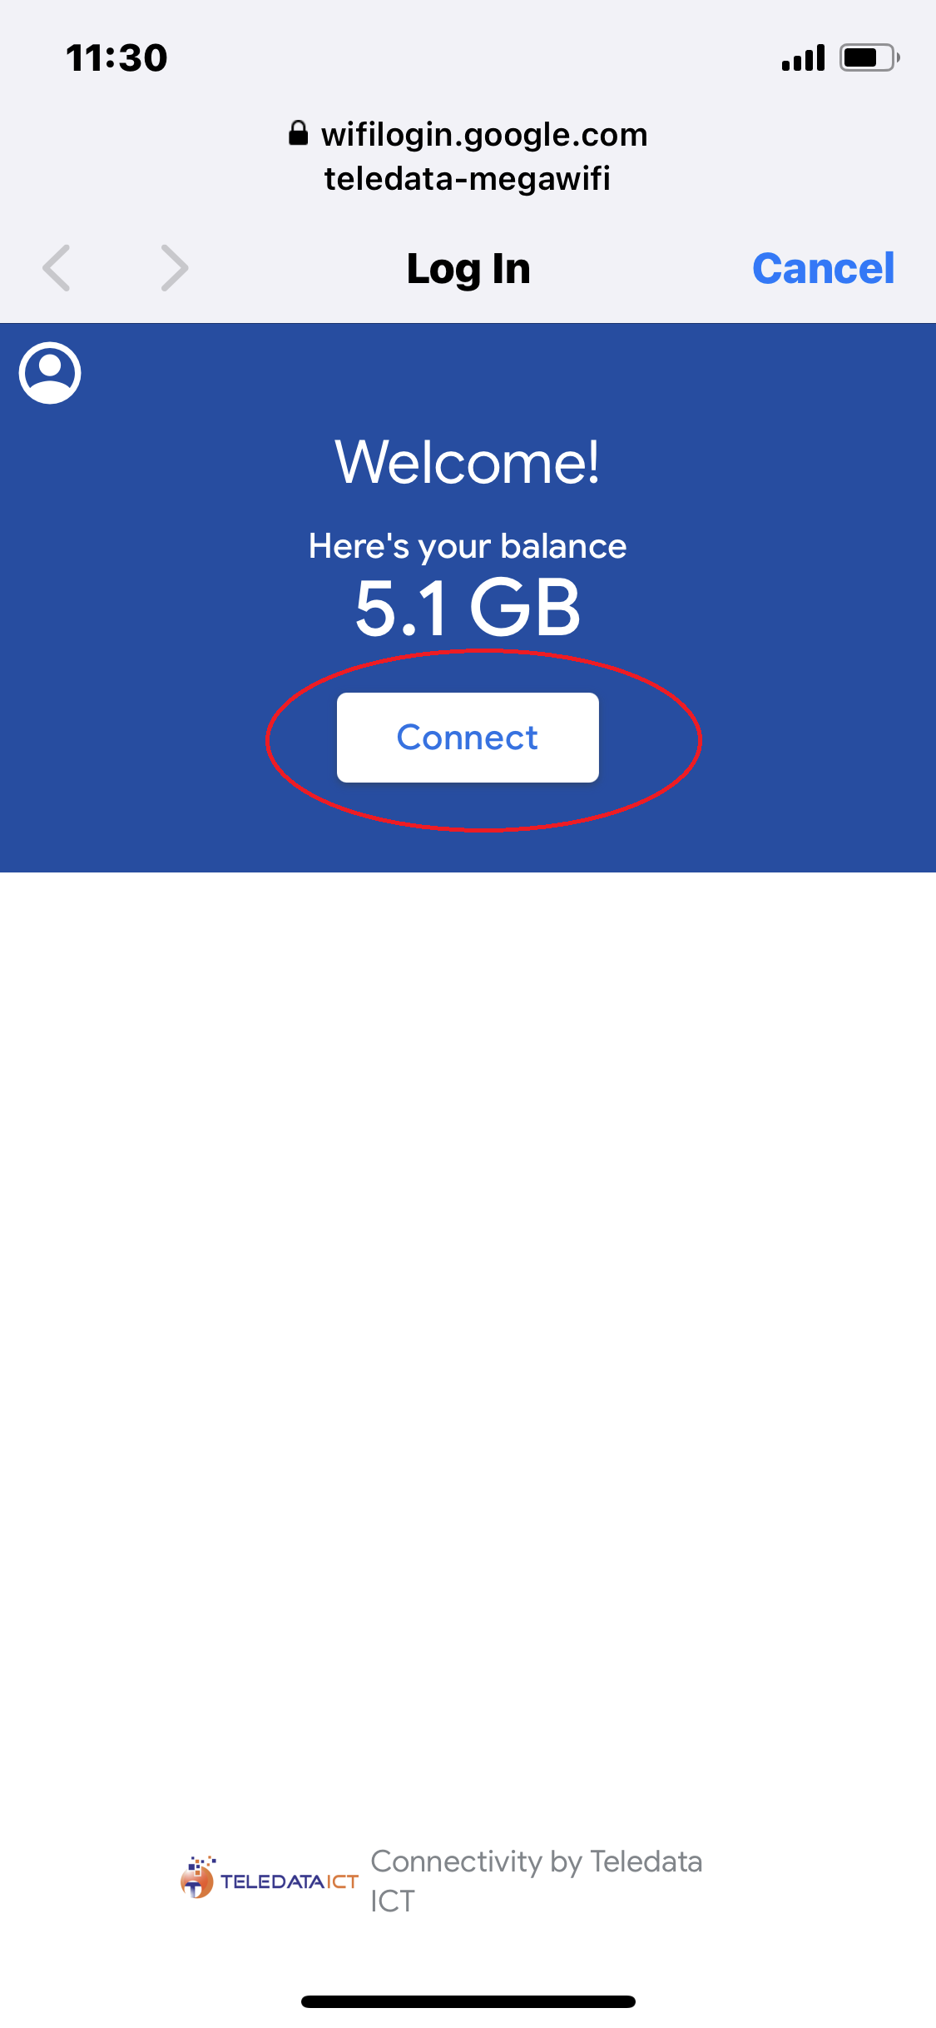
- Tap on Start Browsing.
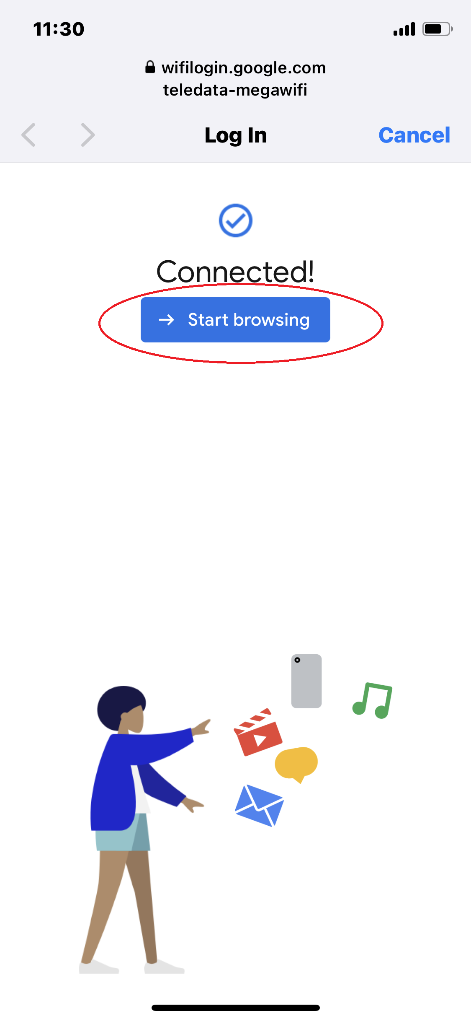
- Voila! You are now connected
